*Project 2 - Titanic Data Analysis*

Created Dir ‘titanicdata’ in hdfs and folder ‘titanicdata’ in local system.  
Pasted the downloaded file ‘TitanicData.txt’ into the folder ‘titanicdata’.  
After running with flume with the help of modified ‘titanic.conf’ file got the below results: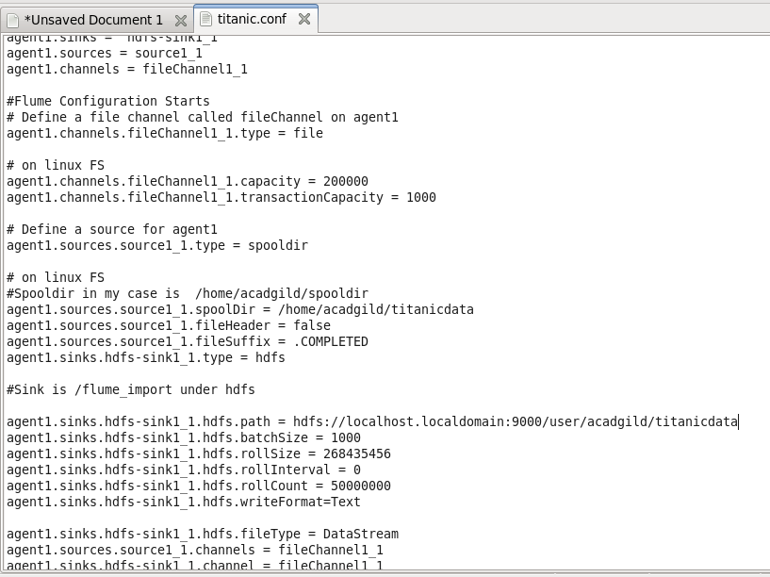

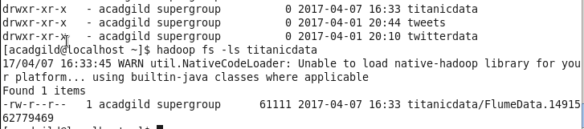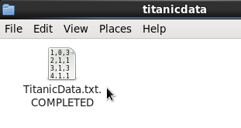

Storing the file from hdfs to hive and inserted the data into the table created in hive ‘titanicdata’:



Result such as:

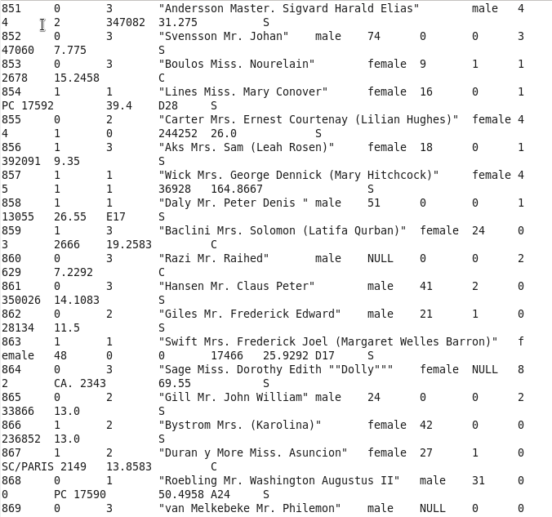

1.In this problem statement we will find the average fare of each class.



2.In this problem statement we will find the number of people alive in each class and are embarked in Southampton.





3. In this problem statement we will find out number of male and female people died in each class.



